Visualizing Geospatial Data

**Introduction to Folium**

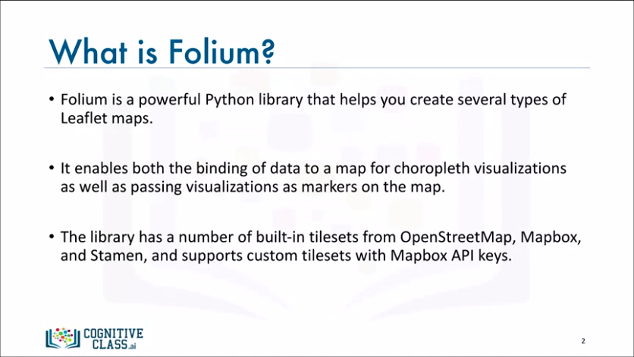

* Folium is a powerful data visualization library in Python that was built primarily to help people visualize geospatial data. With Folium, we can create a map of any location in the world as long as we know its latitude and longitude values.
* We can also create a map and superimpose markers as well as clusters of markers on top of the map for cool and very interesting visualizations.
* We can also create maps of different styles such as street level map, stamen map, and a couple others.

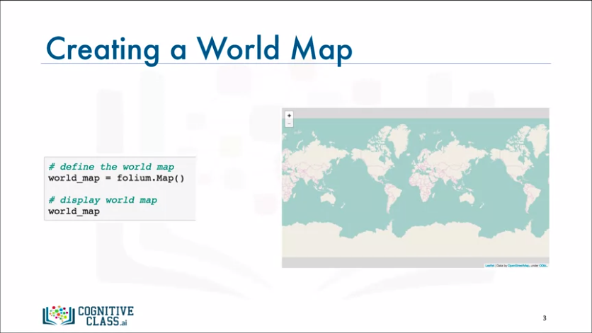

* Creating a world map with Folium is pretty straightforward. You simply call the map function and that is all. What is really interesting about the maps created by Folium is that they are interactive, so we can zoom in and out after the map is rendered, which is a super useful feature. The default map style is the open street map, which shows a street view of an area when you're zoomed in and shows the borders of the world countries when we're zoomed all the way out.

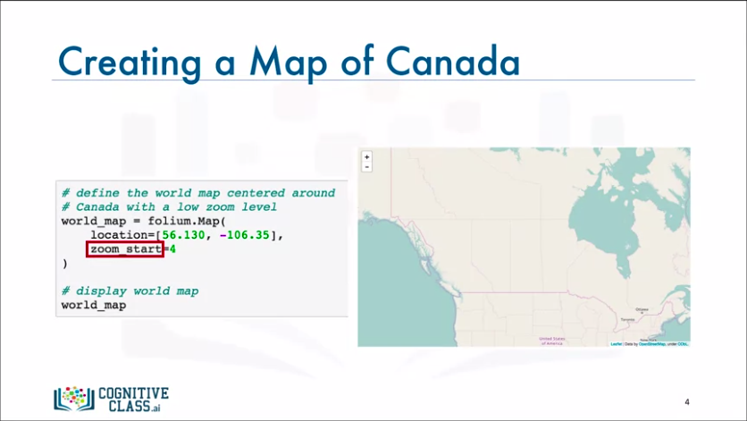

* Now let's create a world map centred around Canada. To do that, we pass in the latitude and the longitude values of Canada using the location parameter and with Folium, we can set the initial zoom level using the zoom start parameter. Now we say initial because we can easily change the zoom level after the map is rendered by zooming in or zooming out. You can play with this parameter to figure out what the initial zoom level looks like for different values. Now, let's set the zoom level for our map of Canada to 4.
* And there we go. On the right is a world map centred around Canada.

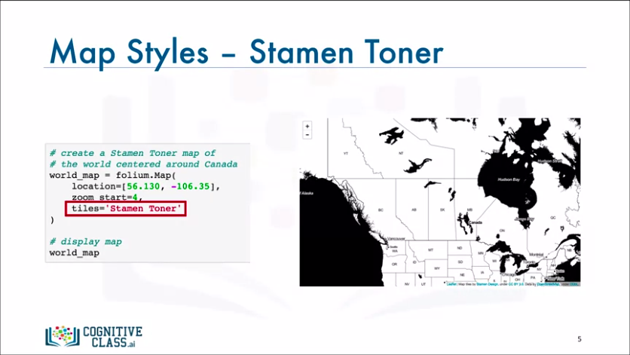

* Another amazing feature of Folium is that you can create different map styles using the tiles parameter. Let's create a stamen toner map of Canada. This style is great for visualizing and exploring river meanders and coastal zones.

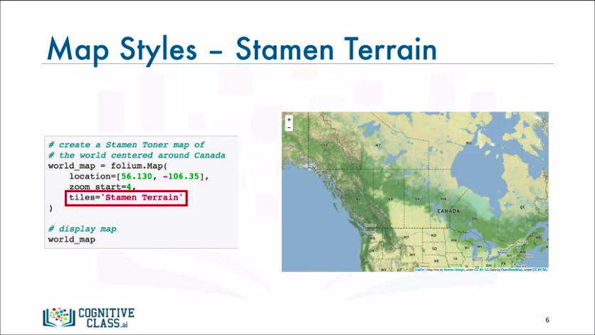

* Another style is stamen terrain. Let's create a map of Canada in stamen terrain. This style is great for visualizing, hill shading and natural vegetation colors.

**Maps with Markers**

We will continue working with the Folium library and learn how to superimpose markers on top of a map for interesting visualizations.

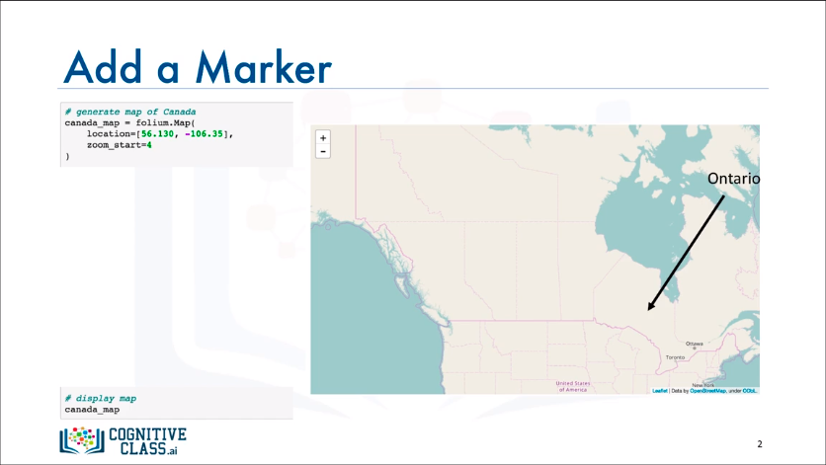

* So, let's create canada map again and name it canada_map. Ontario is a Canadian province and contains about 40 percent of the Canadian population. It is considered Canada's most populous province. Let's see how we can add a circular mark to the centre of Ontario.

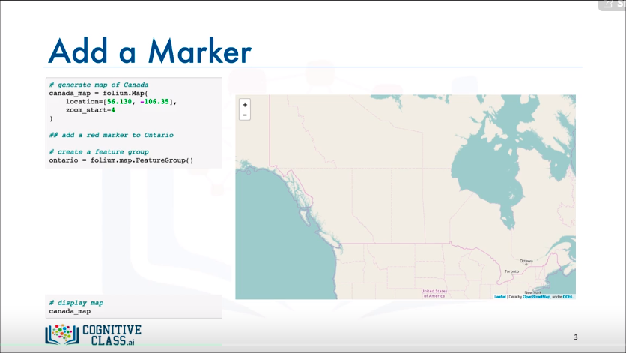

* To do that, we need to create what is called a feature group. Let's go ahead and create a feature group named Ontario. Now when a feature group is created, it is empty and that means what's next is to start creating what is called children and adding them to the feature group.

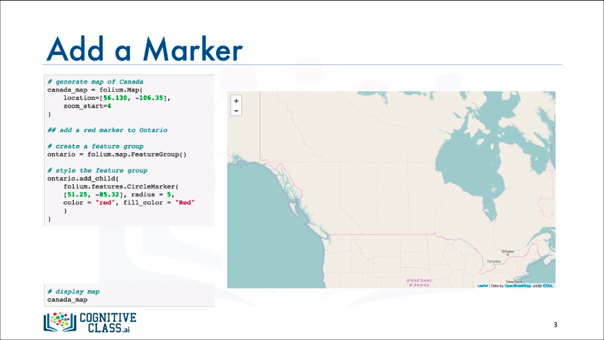

* So let's create a child in the form of a red circular mark located at the centre of the Ontario province. We specify the location of the child by passing in its latitude and longitude values. And once we're done adding children to the feature group, we add the featured group to the map.

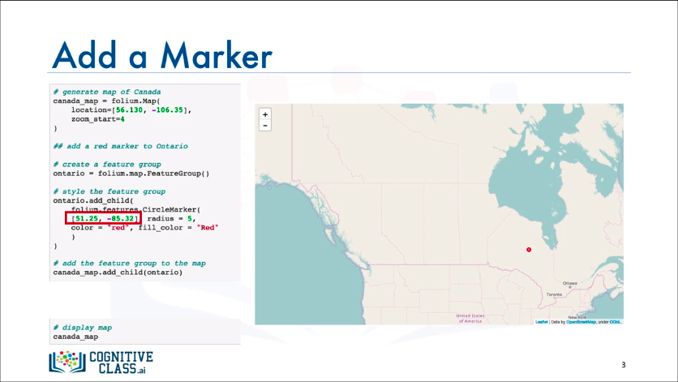

* And there you have it: A red circular mark superimposed on top of the map and added to the centre of the province of Ontario. Now, it would be nice if we could actually label this marker in order to let other people know what it actually represents.

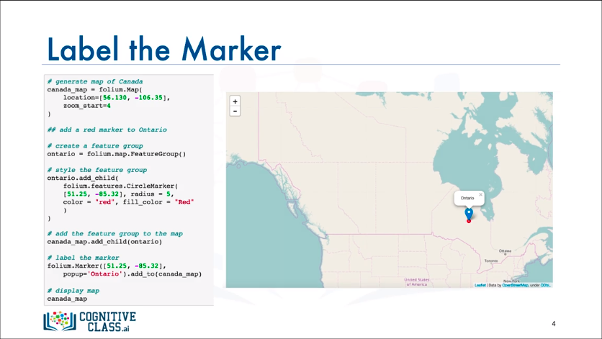

* To do that, we simply use the marker function and the pop up parameter to pass in whatever text we want to add to this marker. And there you go: Now our marker displays Ontario when clicked on.

**Choropleth Maps**

How to create a special type of map called choropleth map with Folium?

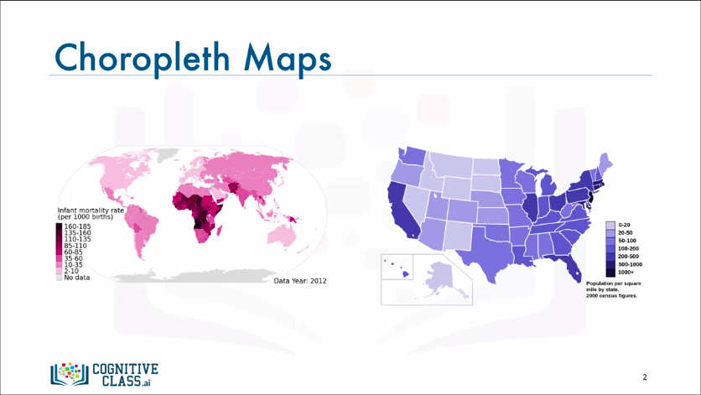

* Most of us have seen maps similar to these two. These are what we call choropleth maps. So what is a choropleth map? A choropleth map is a thematic map in which areas are shaded or patterned in proportion to the measurement of the statistical variable being displayed on the map, such as population density or per capita income. The higher the measurement the darker the color.
* So, the map to the left is a choropleth map of the world showing infant mortality rate per 1000 births. The darker the color the higher the infant mortality rate. According to the map, African countries have very high infant mortality rates with some of them reporting a rate that is higher than 160 per 1000 births.
* Similarly, the map to the right is a choropleth map of the US showing population per square mile by state. Again, the darker the color the higher the population. According to the map, states in the eastern part of the US tend to be more populous than states in the western part, with California being an exception.

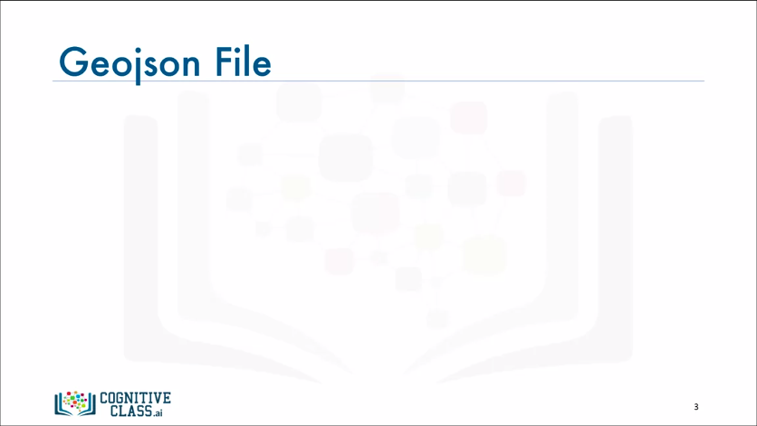

* In order to create a choropleth map of a region of interest, Folium requires a GeoJSON file that includes geospatial data of the region. For a choropleth map of the world, we would need a Geo JSON file that lists each country along with any geospatial data to define its borders and boundaries.

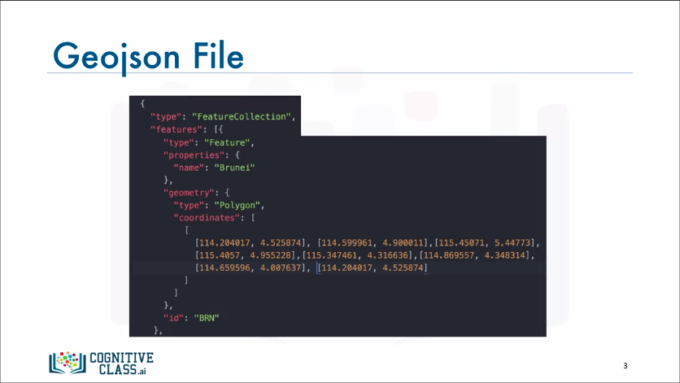

* Here is an example of what the Geo JSON file would include about each country.

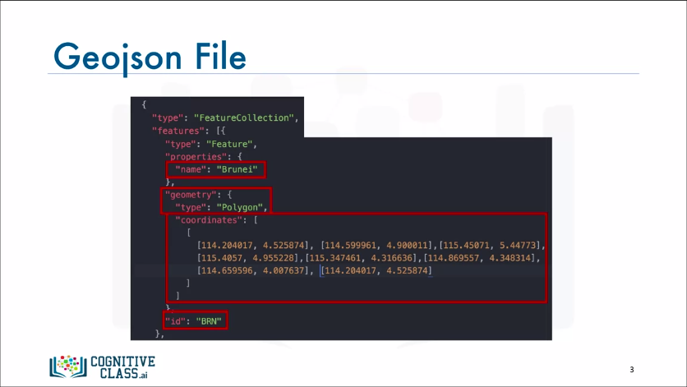

* The example here pertains to the country Brunei. As you can see, the file includes the country's name, it's ID, geometry shape, and the coordinates that define the country's borders and boundaries.

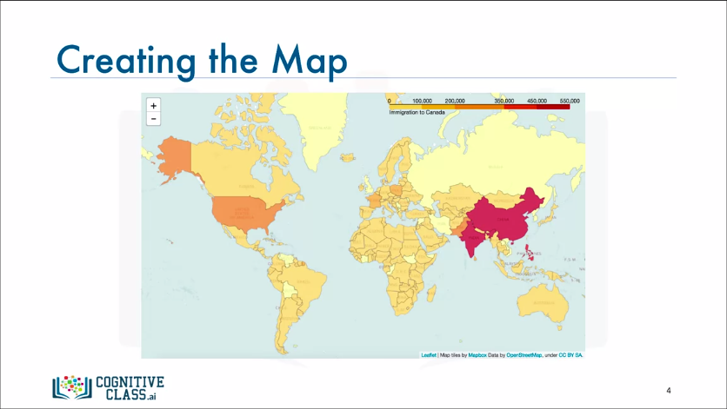

* Let's see how we can generate a choropleth map of the world showing immigration to Canada.

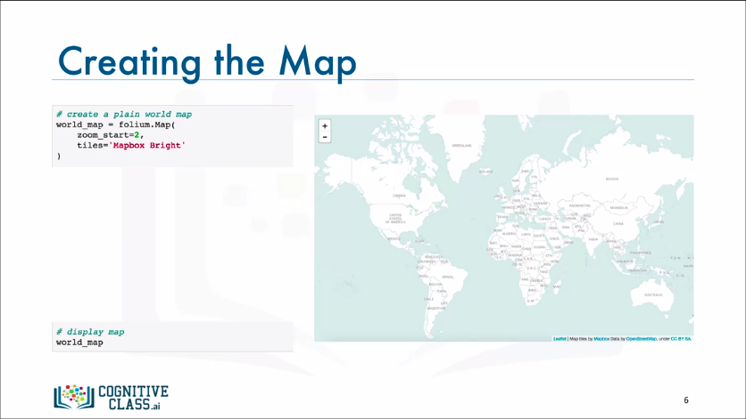

* Let’s go ahead and create a world map, but this time let's use the mapbox bright tiles set. The result is a nice world map displaying the name of every country.

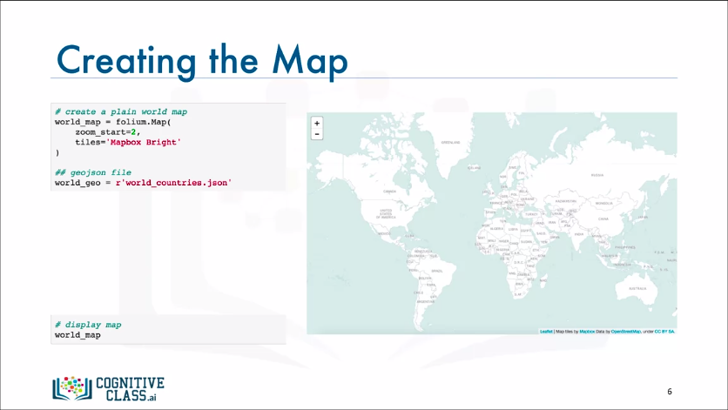

* Now to convert this map into a choropleth map, we first define a variable that points to our GeoJSON file.

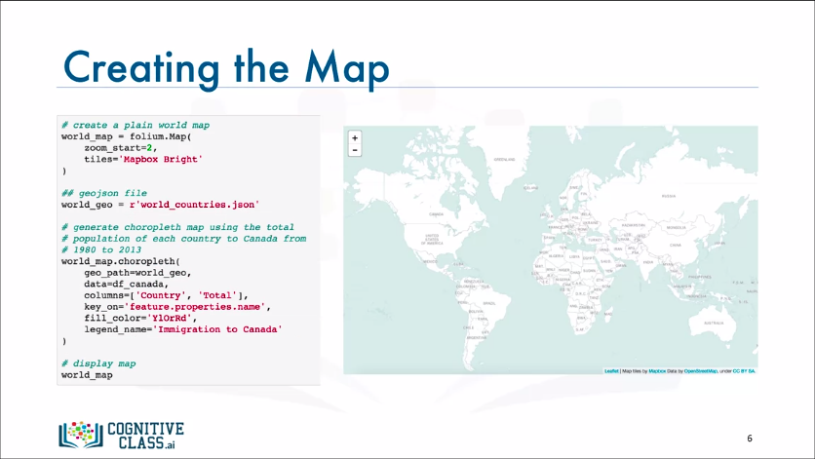

* Then we apply the choropleth function to our world map and we tell it to use the columns "Country" and "Total" in our df_Canada dataframe, and to use the country names to look up the geospatial information about each country in the GeoJSON file.

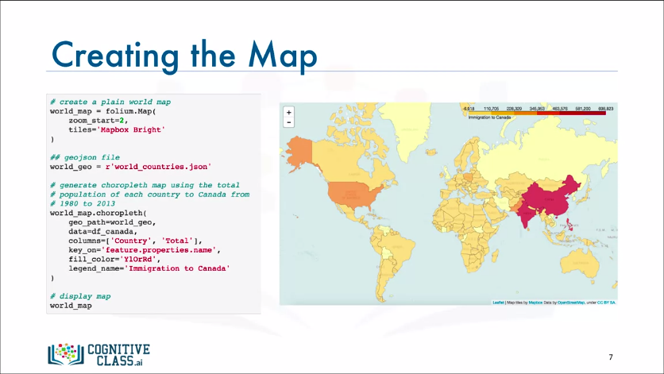

* And there we have it: A choropleth map of Canada showing the intensity of immigration from different countries worldwide.